**COMSATS University Islamabad,   
Park Road, Chak Shahzad, Islamabad Pakistan**

#### Department of Computer Science

**Assignment-03**

CLO-3

Software Design Specification

For

Tranquility: Reduce Depression among Masses

**Submitted By:**

**Syed Abdullah Saad FA19-BCS-077**

**Syed Hussain Haider Bukhari FA19-BCS-078**

**SupervisorMr. Tehseen Riaz Abbasi**

Submission Date: (10-05 -2021)

Original Version 1.0

*Bachelor of Science in Computer Science (2019-2023)*

**Table of Contents**

Revision History iii

1. Introduction 1

2. Design methodology and Software Process Model 1

3. System overview 2

3.1 Architectural Design 2

3.2 Process flow/Representation 3

4. Design models [along with descriptions] 12

Class Diagram: 12

5. Data design 23

5.1 Data dictionary 24

6. Algorithm & Implementation 24

7. Software requirements traceability matrix 24

8. Human Interface Design 26

8.1 Screen images 26

8.2 Screen objects and actions 31

9. Conclusion 32

10. References 32

11. Appendix I 33

12. Plagiarism Report 33

Revision History

|  |  |  |  |
| --- | --- | --- | --- |
| **Name** | **Date** | **Reason for changes** | **Version** |
|  |  |  |  |
|  |  |  |  |

**Application Evaluation History**

|  |  |
| --- | --- |
| **Comments (by course instructor)**  **\*include the ones given at scope time both in doc and presentation** | **Action Taken** |
|  |  |
|  |  |

Supervised by

<Supervisor’s Name>

Signature______________

# Introduction

Tranquility app will be available Android, iOS, and web as well. The app is targeted towards generic audience but can be recommended to highly stressed and depressed people. The app needs a registered account to operate and to access its features. The anonymous access is also available for the user who are privacy conscious. In case of interaction with doctors, the app provides features to book an appointment with the doctors and meet with them online through text, video, and audio calls. Four different types of exercises along with both text manuals and video tutorials are available to help user minimize his/her stress and anxiety levels. The routine manager lets the user customize the routine of his/her daily exercise sessions and keeps a check on user exercise history. The music module is available to the user to listen to the soothing music to calm down and relax. The user can search for a specific song along with options to play, pause, skip, like and download a song. Emergency protocol is implemented in case a user is having negative thoughts and needs someone by his/her side. It sends a SOS message to the emergency contacts set by the user as well as nearby hospitals and clinics registered on the app. Motivational quotes are available to motivate user in a positive way and to increase self-worth and morale of the user. These can be displayed on launching the app as well as can be browsed in the app. The app provides user a space where he/she can connect with other patients all around the world. The user can add other patients as friends along with chatting with them in personal or public rooms. The anxiety check is available to automatically record user’s heartbeat using fitness band. It can measure anxiety levels and recommends best course of actions to the user using app notifications.

# Design methodology and Software Process Model

**Design Methodology:**

Object oriented Methodology will be used to develop the app. As the app is meant to be used by different patients with their own specific data and set of details, the OOP is most suitable for this purpose. For web, JavaScript will be used in object-oriented form.

For OOP, Java and Kotlin are used to produce Android app and swift in used to develop iOS app.

As OOP is implemented, SDS will mostly include Class Diagrams representing inheritance, composition, and relations etc.

**Software Process Model:**

We will use evolutionary process model. A lot of requirements are known upfront but can be changed under development. Mostly, the UI can be requested to change under development so evolutionary process model is used as there will be room for improvement. The main core part of the system will be delivered first and then the system will be updated in incremental order according to the requirements.

# System overview

**Context Diagram:**

## Diagram, schematic Description automatically generatedArchitectural Design

## Process flow/Representation

**Process Flow Diagram:**

**Activity Flow Diagrams:**

Figure 1: Login Process

Figure 2: Set Appointment Process

Figure 3: Add Friend Process

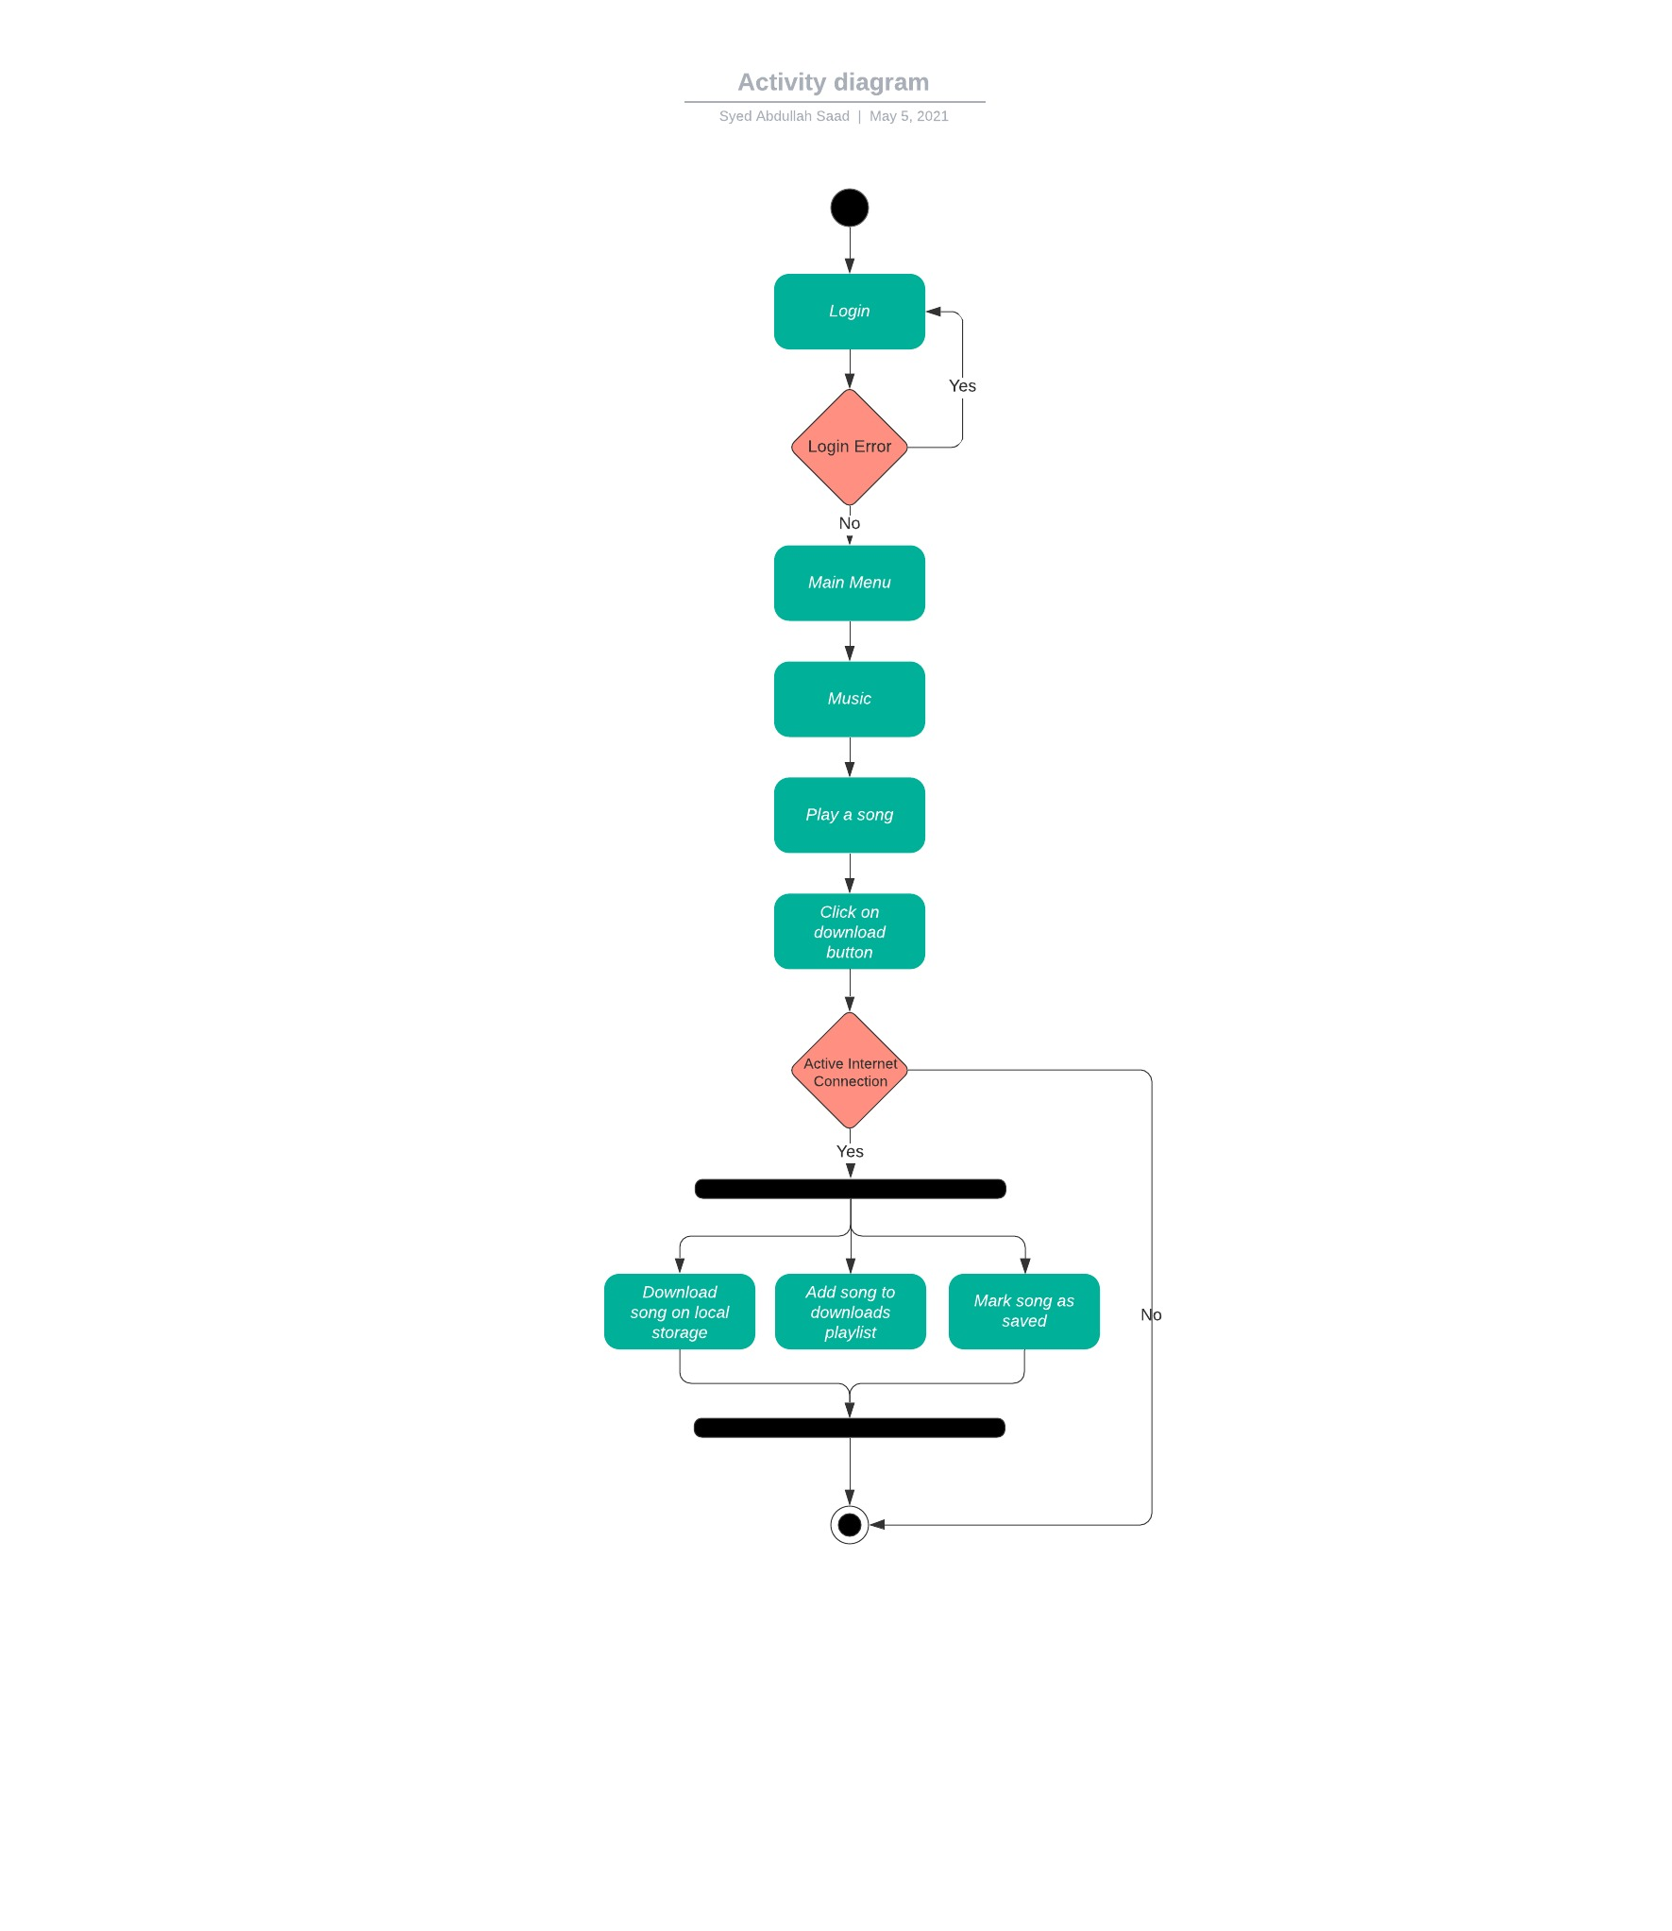

Figure 4: Download Song Process

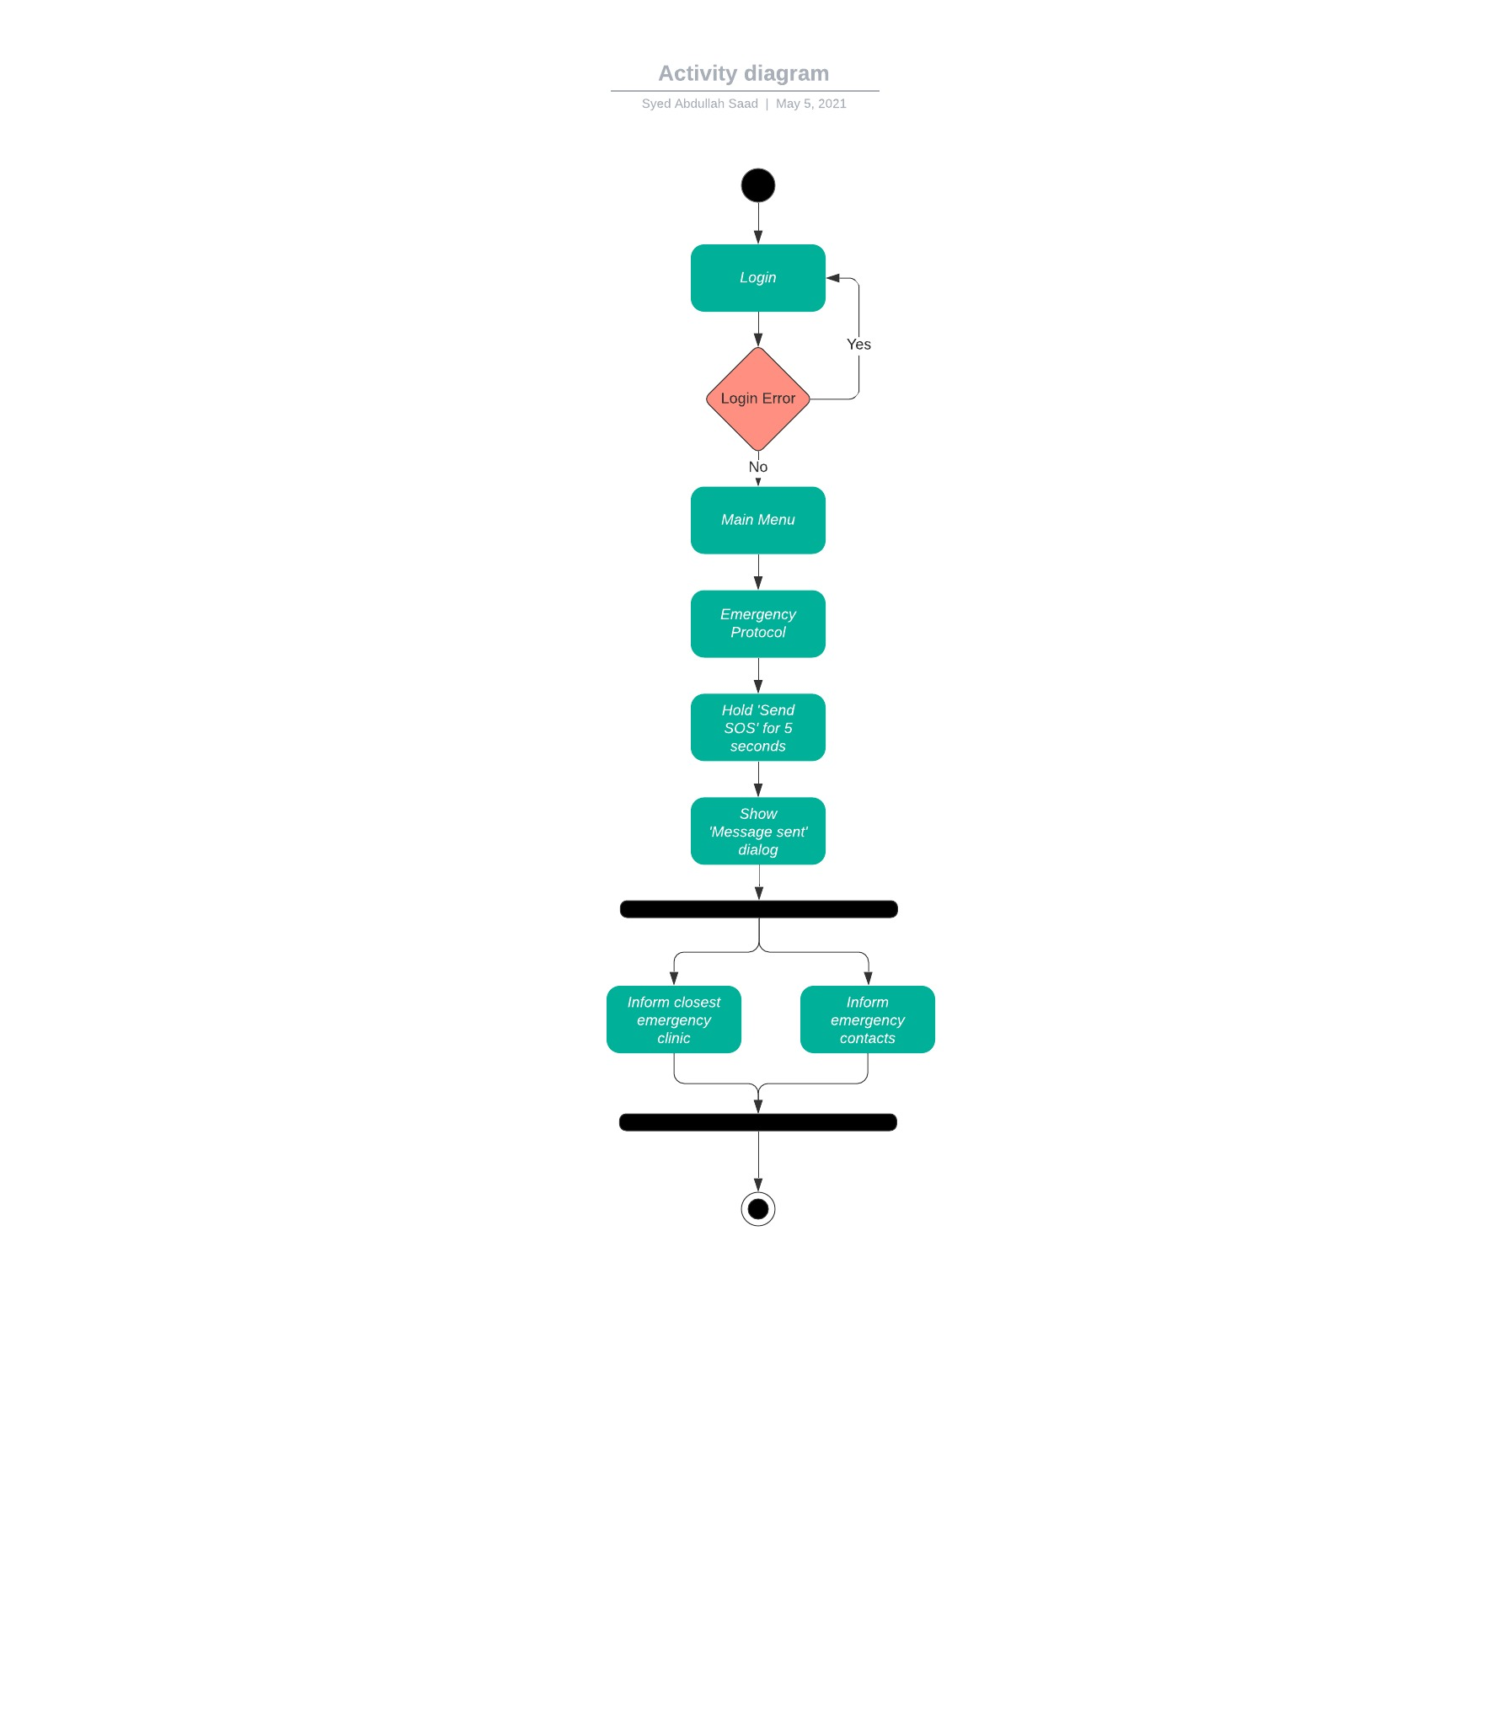

Figure 5: Send SOS Message Process

Figure 6: Exercise Process

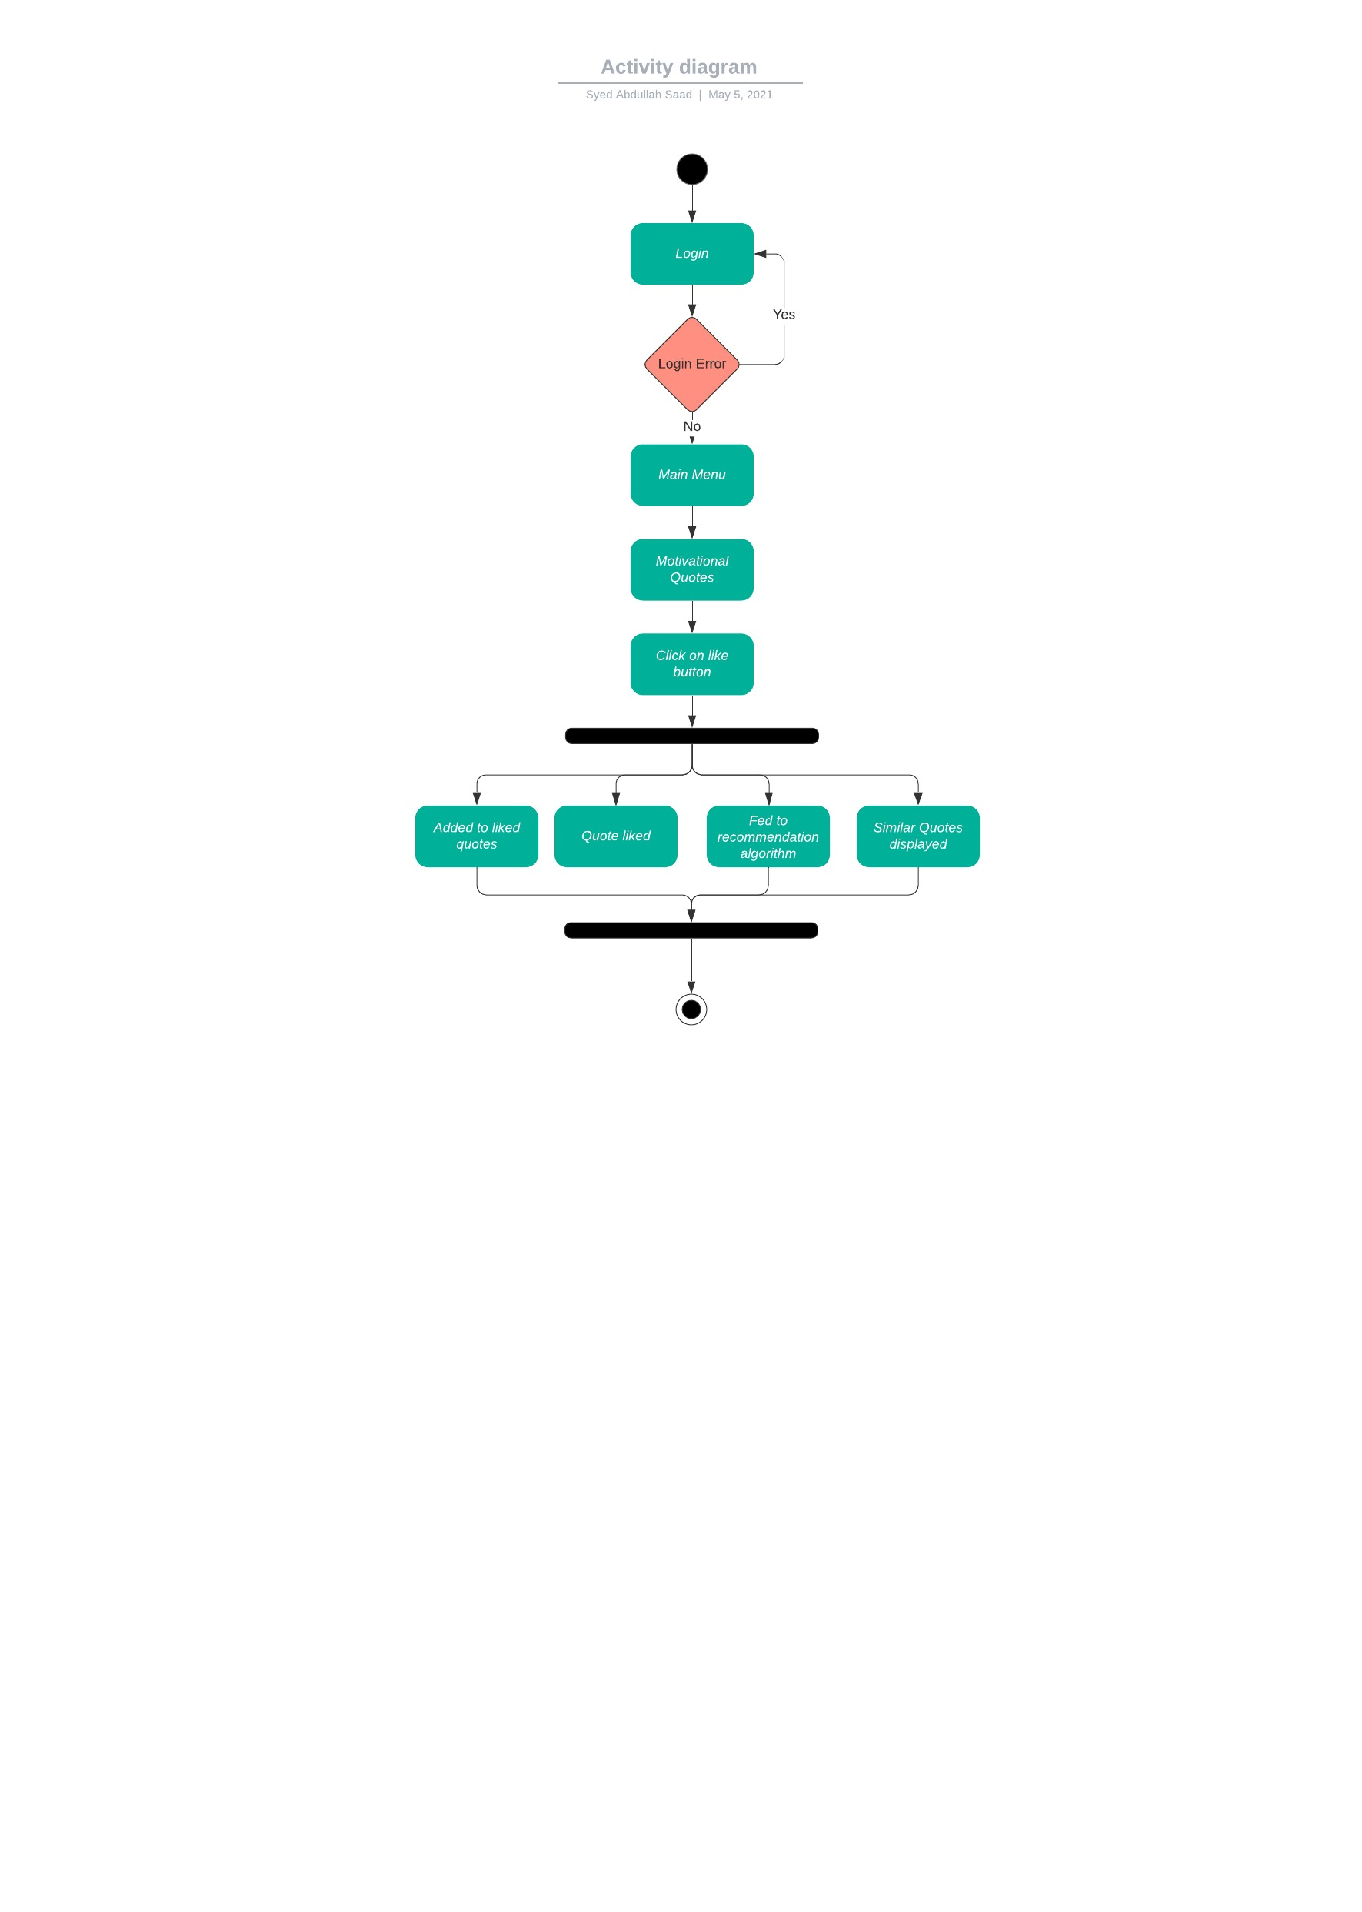

Figure 7: Like Motivational Quotes Process

Figure 8: Set Routine Process

# Design models [along with descriptions]

## Diagram Description automatically generatedClass Diagram:

Figure 9: Class Diagram for Tranquility

**Sequence Diagrams:**

Figure : Login Sequence

Figure : Set Appointment Sequence

Figure : Send SOS Message Sequence

Figure : Add Friend Sequence

Figure : Download Song Sequence

Figure : Start Exercise Sequence

Figure : Like Quote Sequence

Figure : Set Routine Sequence

**State Diagram:**

Figure : State Machine Diagram of Set Appointment

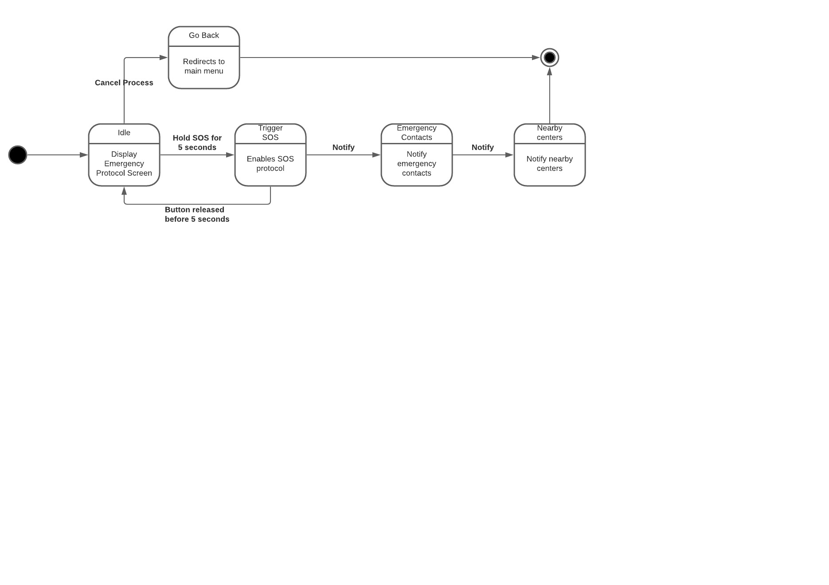

Figure : State Machine Diagram for SOS Message

Figure : State Machine Diagram for Login

# Data design

.

Figure 21: ERD Diagram for Tranquility

## Data dictionary

**Database Relations:**

**Account**(*account_id(PK),* username, password)

**Author**(*author_ID(PK)*, author_name)

**Appointment**(*appointment_id(PK*), appointment_date, appointment_time, reason)

**Artist**(*artist_id(PK),* artist_name)

**Doctor**(*account_id(PK),* name, specialty, experience, qualification, rating)

**Emergency** **Contact**(*contact_number(PK),* contact_name, contact_relation)

**Group** **Chat**(*group_id(PK),* group_name, group_access, group_population)

**Music**(*music_id(PK),* music_name, music_length, music_genre)

**Online** **Profile**(*account_ID(PK),* profile_picture, friend_list, group_list)

**Post**(*post_ID(PK),* post_details, post_content)

**Playlist**(*playlist_id(PK),* playlist_name, playlist_size)

**Quote**(*quote_id(PK),* quote_language, quote_genre)

**Routine** (*account_id(PK)*,routine_date*,* routine time, off_days)

**User**(*account_id(PK),* first_name, last_name, age, gender)

# Algorithm & Implementation

Deep Learning technique is used in our application, deep learning is generally known as a subfield of machine learning which is inspired by the algorithms which are inspired and structured by keeping in view the functionality of human brain. In deep learning, the system trains itself by keeping in view the same pattern as a human brain follows, in liking or hating something. Deep learning is now a days a very vast field and the entire future is based on it.

Deep learning algorithms are used in many sections of our project such as,

In **Music** section, the application recommends the user with the music which he/she likes. Our system uses the **BART (Bandits for recommendations as treatments)** algorithm. By using this, the system analysis the previous raw data of the user and runs the algorithm. The user is recommended with the songs of his/her taste as it keeps the record of the most listened artist as well as the most songs listened of a genre. It works in such a way it tries to avoid recommendations of such songs which are being skipped by the user in the past. If the user listens to a song more than 30 seconds then the songs of that type are put on a higher priority of recommendation. The system always tries to recommend all the unlisten songs or the new ones. So, that the recommendation can be made according to the user taste.

In **Motivational Quotes** section, the application analyzes the liked quotes and the downloaded ones by the user. The system uses the deep learning algorithm which filters the quotes according to the user taste and then it recommends those quotes to the user in the notification section or in the motivational quotes section in our application.

In **Daily Routine** section, our system recommends exercises and sleep time by using deep learning algorithm that works on the daily activity of the user on the application. This algorithm analyses the routine of the user for 14 straight days and after that it uses the neural networks to recommend and predict the sleeping and exercising patterns of the user.

# Software requirements traceability matrix

Table1: Software requirements traceability matrix

|  |  |  |  |
| --- | --- | --- | --- |
| **Reg. Number** | **Use case title** | **Design Component** | **Component item** |
| 1.1 | Sign Up | Class Diagram | signUp() |
| 1.2 | Sign In | Class Diagram | signIn() |
| 1.3 | Forgot Password | Class Diagram | forgotPassword() |
| 1.4 | Remember Me | Class Diagram | rememberMe() |
| 1.5 | Edit Info | Class Diagram | editProfile() |
| 1.6 | Delete Profile | Class Diagram | deleteData() |
| 1.7 | Anonymous Access | Class Diagram |  |
| 2.1 | Making Appointment | Class Diagram | bookAppointment() |
| 2.2 | Canceling Appointment | Class Diagram | cancelAppointment() |
| 2.3 | Modifying Appointment | Class Diagram | editAppointment() |
| 2.4 | Choosing Doctor | Class Diagram | bookAppointment() |
| 2.5 | Voice Calling with Doctor | Class Diagram | voiceCalling() |
| 2.6 | Video Calling with Doctor | Class Diagram | videoCalling() |
| 2.7 | Chatting with Doctor | Class Diagram | textChat() |
| 3.1 | Chatting | Class Diagram | textChat() |
| 3.2 | Group Invitation | Class Diagram | groupInvitation() |
| 3.3 | Add Friend | Class Diagram | addFriend() |
| 3.4 | Remove Friend | Class Diagram | removeFriend() |
| 3.5 | Block Individual | Class Diagram | blockIndividual() |
| 3.6 | Post | Class Diagram | postContent() |
| 3.7 | Like | Class Diagram | Like() |
| 4.1 | Send SOS | Class Diagram | sendSOS() |
| 4.2 | Add Emergency Contacts | Class Diagram | addContact() |
| 4.3 | Remove Emergency Contacts | Class Diagram | removeContact() |
| 4.4 | Edit Emergency Contacts | Class Diagram | editContact() |
| 5.1 | Set Daily Routine | Class Diagram | setRoutine() |
| 5.2 | Modify Routine | Class Diagram | editRountine() |
| 5.3 | Set Remainder | Class Diagram | setRemainder() |
| 5.4 | Set Off Days | Class Diagram | setOffDays() |
| 5.5 | Predict Routine | Class Diagram | predictRountine() |
| 6.1 | Listen Song | Class Diagram | play() |
| 6.2 | Search Song | Class Diagram | search() |
| 6.3 | Skip / Revert Song | Class Diagram | skip() |
| 6.4 | Favorite Song | Class Diagram | favorite() |
| 6.5 | Download Song | Class Diagram | download() |
| 6.6 | Play / Pause | Class Diagram | play() |
| 6.7 | Repeat | Class Diagram | revert() |
| 6.8 | Sleep Timer | Class Diagram | setSleepTimer() |
| 6.9 | Recommend Music | Class Diagram | recommendMusic() |
| 7.1 | Breathing | Class Diagram | performExercise() |
| 7.2 | Meditation | Class Diagram | performExercise() |
| 7.3 | Sleep | Class Diagram | performExercise() |
| 7.4 | Relaxation | Class Diagram | performExercise() |
| 7.5 | View Manual | Class Diagram | viewManual() |
| 7.6 | View Video Tutorial | Class Diagram | viewVideoTutorial() |
| 8.1 | Like Quote | Class Diagram | Like() |
| 8.2 | Favorite Quote | Class Diagram | favorite() |
| 8.3 | Download as Wallpaper | Class Diagram | download() |
| 8.4 | Select Quote Types | Class Diagram | selectType() |
| 8.5 | Select Authors | Class Diagram | selectAuthor() |
| 8.6 | Select Language | Class Diagram | selectLanguage() |
| 8.7 | Recommend Quotes | Class Diagram | recommendQuotes() |

# Human Interface Design

Describe the functionality of the system from the user’s perspective. Explain how the user will be able to use your system to complete all the expected features and the feedback information that will be displayed for the user.

## Screen images

Figure : Interface-1-Set Appointment of Tranquility (Web)

Figure : Interface-2-Call Doctor of Tranquility (Web)

Figure : Interface-3-Emergency Protocol of Tranquility (Web)

Figure : Interface-4-Set Appointment of Tranquility (Smartphone)

Figure : Interface-5-Exercises of Tranquility (Smartphone)

Figure : Interface-6-Music of Tranquility (Smartphone)

## 8.2 Screen objects and actions

|  |  |  |  |
| --- | --- | --- | --- |
| **Screen** | **Object** | **Name** | **Action** |
| Sign-in | Text field | Email | User will enter their email. |
| Sign-in | Text field | Password | User will enter their password |
| Sign-in | Button | Forgotten password | Redirect user to reset password window |
| Sign-in | Button | Sign Up | Redirect user to sign up window |
| Sign-in | Button | Sign-in | Verify credentials and sign user in |
| Sign-in | Button | Anonymous Access | Access user to app without login |
| Sign Up | Text field | Email | User will enter their email. |
| Sign Up | Text field | Password | User will enter their password |
| Sign Up | Text field | Name | User will enter their name |
| Sign Up | Combo Box | Gender | User will select their gender |
| Sign Up | Text field | Age | User will enter their age |
| Sign Up | Button | Sign-up | Checks data and updates database. |
| Sign Up | Button | Sign In | Redirect user to sign-in window |
| Main Menu | Button | Online Doctor | Redirects user to online doctor window |
| Main Menu | Button | Online Community | Redirects user to online community window |
| Main Menu | Button | Emergency Protocol | Redirects user to emergency protocol window |
| Main Menu | Button | Music | Redirects user to music window |
| Main Menu | Button | Routine Manager | Redirects user to routine manager window |
| Main Menu | Button | Exercises | Redirects user to exercises window |
| Main Menu | Button | Motivational Quotes | Redirects user to motivational quotes window |
| Main Menu | Button | Profile Management | Redirects user to profile management window |
| Main Menu | Button | Logout | Logs user out and redirects user to login window |
| Set Appointment | Date Box | Select Date | User will select the user to select a date for appointment |
| Set Appointment | Time Box | Select Time | User will the user to select a time for appointment |
| Set Appointment | Text field | State Reason | User will state the reason for appointment |
| Set Appointment | Button | Confirm | User will confirm details of appointment and DB stores data |
| Set Appointment | Button | Go Back | Redirect user to main menu window |
| Doctor Profile | Button | Chat | User can chat with the doctor |
| Doctor Profile | Button | Voice Call | User can voice call the doctor |
| Doctor Profile | Button | Video Call | User can video call the doctor |
| Doctor Profile | Button | Go Back | Redirect user to main menu window |
| Exercise | Button | Breathing | User can conduct breathing exercises |
| Exercise | Button | Relaxation | User can conduct relaxation exercises |
| Exercise | Button | Meditation | User can conduct meditation exercises |
| Exercise | Button | Sleeping | User can conduct sleeping exercises |
| Emergency Protocol | Button | Send SOS Message | User can send SOS message |
| Emergency Protocol | Button | Edit Emergency Contacts | User can edit emergency contacts |
| Emergency Protocol | Button | Go Back | Redirect user to main menu window |
| Music | Button | Play / Pause | Allows the user to play/pause the music |
| Music | Button | Skip | Allows the user to skip the music |
| Music | Button | Revert | Allows the user to revert the music |
| Music | Button | Search Song | Allows the user to search the music |
| Music | Button | Favorite | Allows the user to favorite the current music |
| Music | Button | Download | Allows the user to download the current music |
| Music | Button | Go Back | Redirect user to main menu window |
| Motivational Quotes | Button | Next | User goes to next motivational quote |
| Motivational Quotes | Button | Previous | User goes to previous motivational quote |
| Motivational Quotes | Button | Like | User likes the quote |
| Motivational Quotes | Button | Download | User downloads the quote as wallpaper |
| Motivational Quotes | Button | Copy | User copies the quote in the clipboard |
| Motivational Quotes | Button | Go Back | Redirect user to main menu window |

# Conclusion

This document includes all the design work of every aspect of the project. The implementation will be done based on the design described in the document. The OOP programming will be done according to the class diagram provided and the sequence of use cases will be implemented using process flow diagrams. The interaction between the app and the servers will be implemented using sequence diagrams. Thus, the document provides the complete design and structure of the project to be implemented.

# References

None.

# Appendix I

* How to design using UML (OOP): For guidance please follow the instructions mentioned in the link: http://agilemodeling.com/artifacts/
* How and when to design ER diagrams: For guidance please follow the instructions mentioned in the link:

<http://people.inf.elte.hu/nikovits/DB2/Ullman_The_Complete_Book.pdf>

* Data flow diagrams: For guidance please follow the instructions mentioned in the link and book:
  + http://www.agilemodeling.com/artifacts/dataFlowDiagram.htm
  + Software Engineering –A Practitioner’s approach by Roger Pressman
* Architecture diagram: For guidance please follow the instructions mentioned in the link and book:
  + Ian Sommerville – Software Engineering 9th Edition– Chapter 6

# Plagiarism Report

